DEVELOPMENT ASSESSMENT REPORT
Proposed health services facility
Bonney Street, Wilcannia

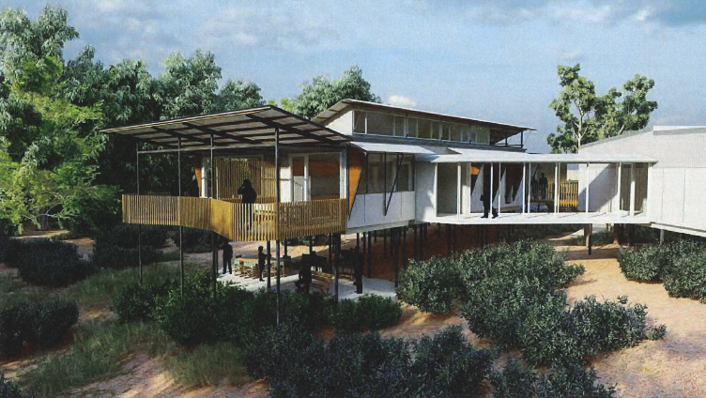

Environmental Assessment Report
Section 4.15 of the Environmental Planning & Assessment Act 1979

June 2022

Prepared by Blacktown City Council on behalf of Central Darling Shire Council

EXECUTIVE SUMMARY
This report provides an assessment of an integrated development application (DA20/21) (Panel Ref PPSWES-122) lodged on 1 December, 2021 for the re-development of land in Bonney Street, Wilcannia. The applicant is the Maari Ma Aboriginal Health Corporation Pty Ltd and the proposal is located within the Central Darling Shire Council local government area.
The proposal seeks approval for the construction of a single storey (but elevated over an undercroft area) health services facility, split into 3 separate buildings connected by 2 covered walkways. These 3 buildings will house a ‘keeping well’ section, ‘nerve centre’ and ‘healthy start’. The functions of these buildings will be outlined in more detail later in this report. The development also comprises civil works to provide car parking, road works to provide access/parking and landscaping throughout the site.
The land was recently reclassified from community land to operational land in accordance with Clause 5.2 (Classification and reclassification of public land) of Central Darling Local Environmental Plan 2012.
The proposal has a capital investment value of $6,356,659. Accordingly, it is Regionally Significant Development under Part 2.4 and Schedule 6 of State Environmental Planning Policy (Planning Systems) 2021 (as it has a CIV of greater than $5 million) and is a ‘health services facility’.
The application was publicly exhibited until 18 February, 2022 and no submissions were received.
A Flood Study Report was prepared for the Wilcannia Wellbeing Centre by Tonkin dated 1 April 2022. The assessment is constrained by the lack of any overall flood study for the Darling River around Wilcannia to establish a definitive 1% AEP flood level. This means that the evidence based on historical flood records is necessary to determine the appropriateness of the nominated floor level in the proposed design.
The Flood Level, Wilcannia Health Clinic report by Barnson Pty Ltd dated 13 May 2021 identifies that the proposed floor level of RL 77.42 m AHD matches the floor level of the adjacent hospital. Based on this and the assessment undertaken by the consultant and Blacktown City Council’s Stormwater Engineer, the proposed finished floor level of 77.42 m AHD is supported.
To better manage the potential impacts of flooding, additional conditions have been recommended to ensure structural protection to the buildings during a flood and by requiring a flood management plan to better manage the impacts of the floods both during and after a major event.
Our assessment concludes that the built form of the proposed development is acceptable within the context of the surrounding residential area, the hospital, the Darling River, foreshore and nearby items of environmental heritage and will not result in any adverse environmental or amenity impacts on the site or the wider locality.
We are also satisfied that the traffic and parking generated by the proposed development can be accommodated within the local road network. Any noise impacts would be appropriately managed through recommended conditions of consent.
We consider that the proposal would provide significant public benefits as it will deliver health infrastructure and services for the community, particularly the Aboriginal community of Wilcannia and its surrounds, without unreasonably affecting public access to the Darling River. It will improve health services in the region, reduce pressure on the local hospital and upgrade an existing service located elsewhere in the town in a more accessible manner.
We conclude that the impacts of the development are acceptable and can be appropriately mitigated through the recommended conditions of consent. We believe that the development is in the public interest and should be approved, subject to conditions.
Table of contents
- BACKGROUND
  - Introduction 4
  - The site and surroundings 4
  - Key issues 6
- DESCRIPTION OF PROPOSAL
  - Description of proposal 7
  - Project need and justification 8
  - Strategic context 8
- STATUTORY CONTEXT
  - Zoning 9
  - Permissibility 9
  - Integrated Development 10
  - Consideration of environmental planning instruments and DCPs 11
  - Objects of the Environmental Planning & Assessment Act 1979 11
- CONSULTATIONS AND SUBMISSIONS
  - Exhibition 13
  - Public authority submissions 13
- ASSESSMENT

Section 4.15(1) matter for consideration 13
  - Environmental Planning Instruments 13

State Environmental Planning Policy (Planning Systems) 2021 13

State Environmental Planning Policy (Resilience and Hazards) 2021 13

Central Darling Local Environmental Plan 2012 15
  - Key assessment issues
          - Flooding 22
          - Voluntary Planning Agreement 23
          - Ownership 23
          - Continued public access to the Darling River 23
          - Matters raised by the Western Regional Planning Panel at the Briefing held on 15 February, 2022 23
  - Built form and urban design 27
  - Aboriginal Heritage 27
  - European heritage 29
  - Biodiversity 30
  - Traffic and parking 30
  - Noise and vibration 31
  - Bushfire 31
  - Waste management 33
  - Crime prevention through environmental design 33
  - Disabled access 34

5.13 Landscaping & tree retention 34
5.14 Contamination 34
5.15 Visual impacts 35
- CONCLUSION AND RECOMMENDATION 35
Attachments
Attachment 1 – Pre-lodgement notes
Attachment 2 – Record of Briefing Western Regional Planning Panel 15 February, 2022
Attachment 3 – Record of Briefing Western Regional Planning Panel 17 May, 2022
Attachment 4 – Copy of plans
Attachment 5 – Draft conditions of consent
            - BACKGROUND
  - Introduction
This report provides an assessment of a development application for the construction of a single storey (elevated over undercroft) health services facility comprising of 3 buildings connected by 2 covered walkways, site works, landscaping and the provision of 16 at-grade carparking spaces (being 4 on-site and 12 within the road reserve of Bonney Street), drop-off area and ambulance bay.
The application was lodged by Maari Ma Aboriginal Health Corporation Pty Ltd on 1 December, 2021. The development is Nominated Integrated Development, with some works being located within 40m of the top of the bank of the Darling River. The development is not Designated Development.
This assessment has been undertaken by officers from Blacktown City Council to assist Central Darling Shire Council as a result of resourcing issues and impacts directly and indirectly relating to the Covid-19 pandemic, as well as being a neutral assessor having regard to the ownership of the land (until 23 May, 2022) by Central Darling Shire Council.
An inspection of the site was undertaken on 30 December, 2020 in anticipation of this development application being lodged and in order to assist the applicant to prepare for lodgement of the application and a subsequent pre-lodgement meeting held via a Video Conference on 28 January, 2021. A copy of the pre-lodgement notes is at Attachment 1.
The applicant briefed the Western Regional Planning Panel on 15 February, 2022 and officers from Blacktown City Council were also in attendance in the video conference to assist the Panel. A copy of the Record of Briefing is at Attachment 2. The Panel inspected the site with a representative of Central Darling Shire Council on 18 March, 2022. An update briefing was also held on 17 May, 2022 in order to review where the matter was up to in terms of reporting and documentation. A copy of the Record of Briefing is at Attachment 3.
  - Site and surrounds
The site is located to the south-west of Ross Street off a short section of unsealed road known as Bonney Street, Wilcannia. The Darling River is located to the south of the site and Wilcannia Hospital to the east. Residential properties are located to the north, north-east and west.
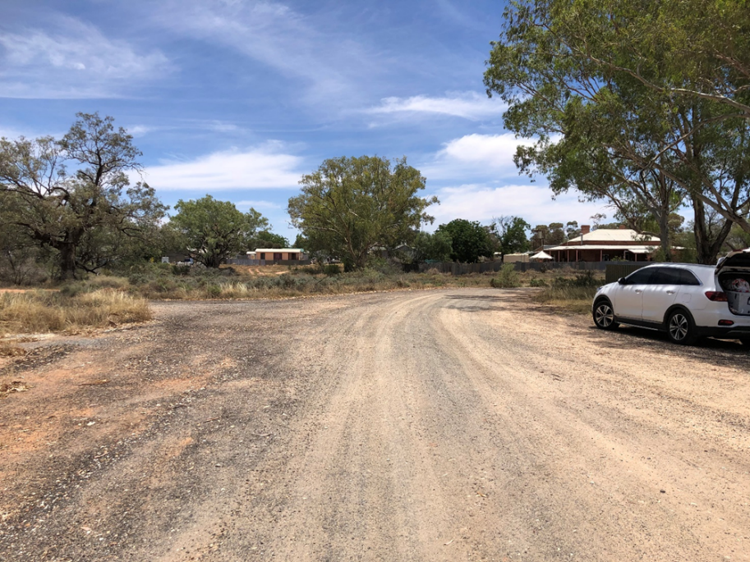
View of the site looking north along Bonney Street
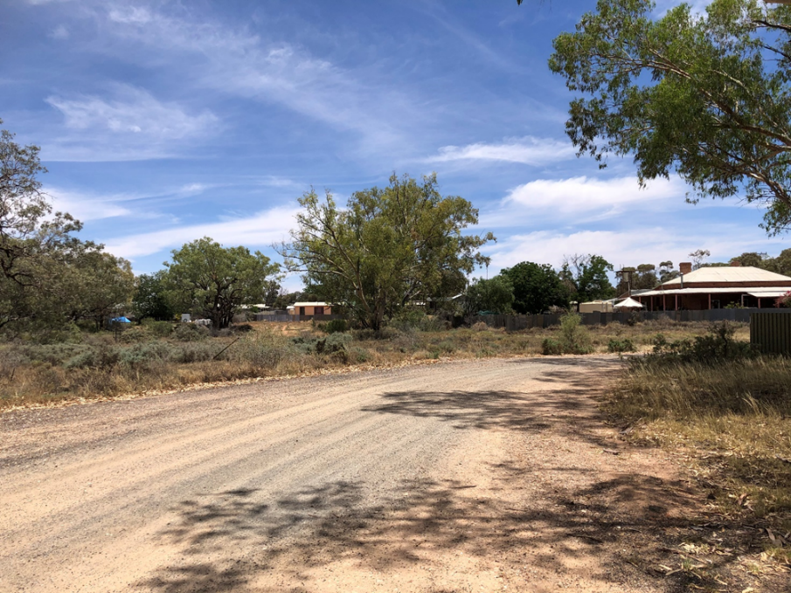
View of the site looking north-west from unsealed Bonney Street – looking towards residential properties adjacent to the site
The development site comprises the following parcels:
- Lots 2-4 in DP 1201089
- Lot 111 in DP 1201028
- Part of the Bonney Street road reserve (for access and designated parking)
The land is of an irregular shape, comprising a number of lots and with a total site area of 5,048m². The land is zoned R1 – General Residential. With part of the access pathway to the Darling River being located on W1 – Natural Waterways zoned land on the upper banks.
The site is generally flat, with undulations of soil and gravel with grasses and small-medium sized native trees. It slopes more progressively towards the river at the rear (southern side). Access also seems to have been informally provided off Bonney Street to the rear of properties located in Bourke Street (to the west) as well as to the pump station located between the subject site and the hospital (to the east). This access will be maintained.
The project location and zoning is shown highlighted on the following figures.
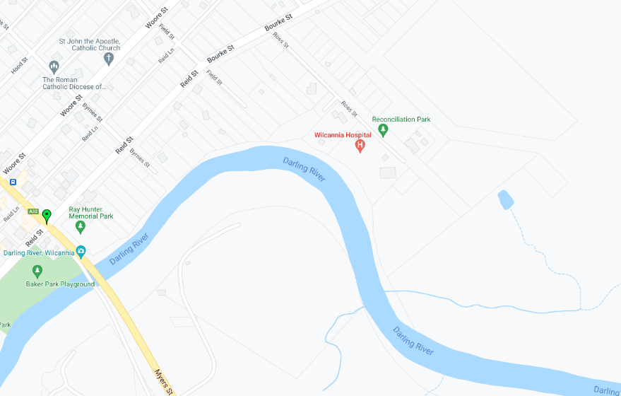
Nearmap
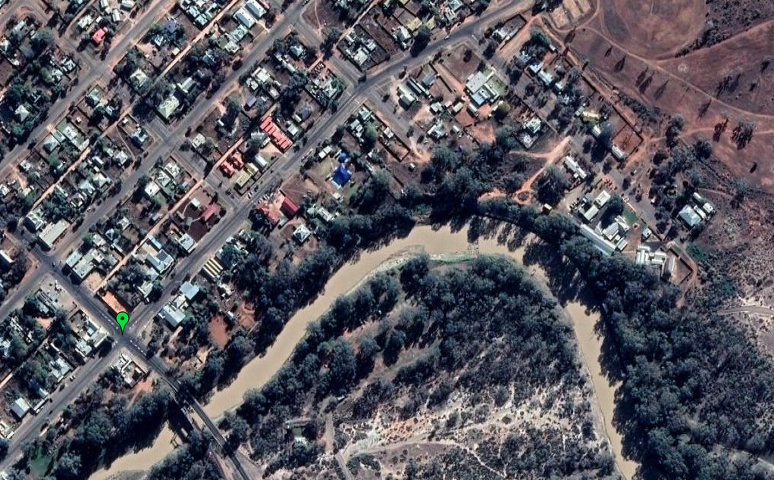
Nearmap
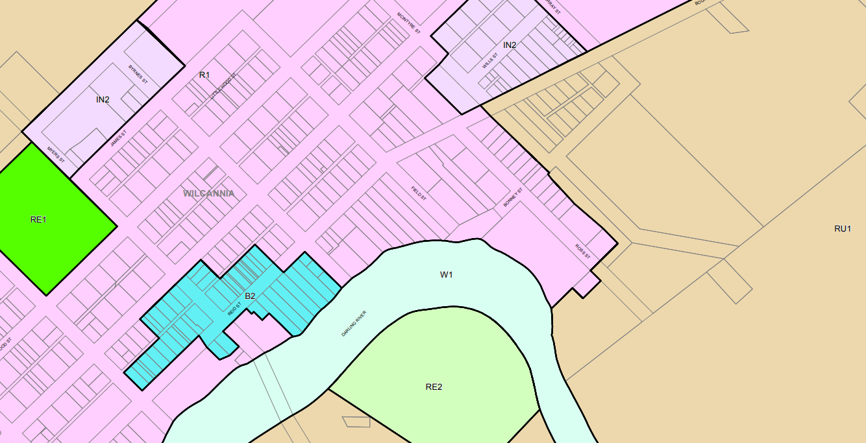
Planning Portal - zoning (LZN_006A)
  - Key issues
The key issues in our assessment of this application are:
- Flooding
- Voluntary Planning Agreement
- Ownership
- Continued public access to the Darling River
- Matters raised by the Western Regional Planning Panel at the briefing held on 15 February, 2022.
These issues are discussed later in this report.

            - DESCRIPTION OF PROPOSAL
2.1 Description of proposal
The key components and features of the proposal are provided in Table 1 and the site plan below.
Aspect | Description
Built form | - Single storey 130m² floor area ‘Keeping Well’ building at the south-eastern part of the site containing 2 treatment rooms, 3 consultation rooms, mental health room and bathrooms  - Single storey 200m² floor area ‘Nerve Centre’ building in the centre of the site containing entry deck, staff office spaces, waiting deck areas (including pram and mobility scooter areas), bathrooms, reception,  - Single storey 130m² floor area ‘Healthy Start’ building at the north-western part of the site containing 3 consultation rooms, bathrooms, cleaner/storeroom, meeting room, staff room and 2 river view deck spaces.  - East and west corridor links connecting the 3 buildings  - Metal roofing over the buildings and links  - Fibre cement and metal wall sheeting  - Cypress pine and fibreglass mesh decking  - Decorative metal screens and panels  - Steel columns
Ancillary facilities | - Garden deck  - Sculpture garden  - Ambulance drop off & turning apron  - Disabled ramp  - Drop off  - Plant and generators  - Community gathering and river lookout adjacent to the top of the bank of the Darling River  - Photovoltaic panels to provide solar access to each of the 3 buildings  - Landscaping utilising a range of endemic and native species.  - Drainage and civil works
Subdivision | The land will be consolidated as part of this development
Carparking | 4 spaces (including 2 disabled accessible spaces will be provided on the subject land)  A further 12 spaces will be provided within the road reserve of Bonney Street, as part of a Voluntary Planning Agreement between Maari Ma Health Aboriginal Corporation and Central Darling Shire Council which includes infrastructure works to facilitate access, drainage and visitor/staff parking within the road reserve at no cost to Council.
Table 1
A copy of the plans is at Attachment 4.

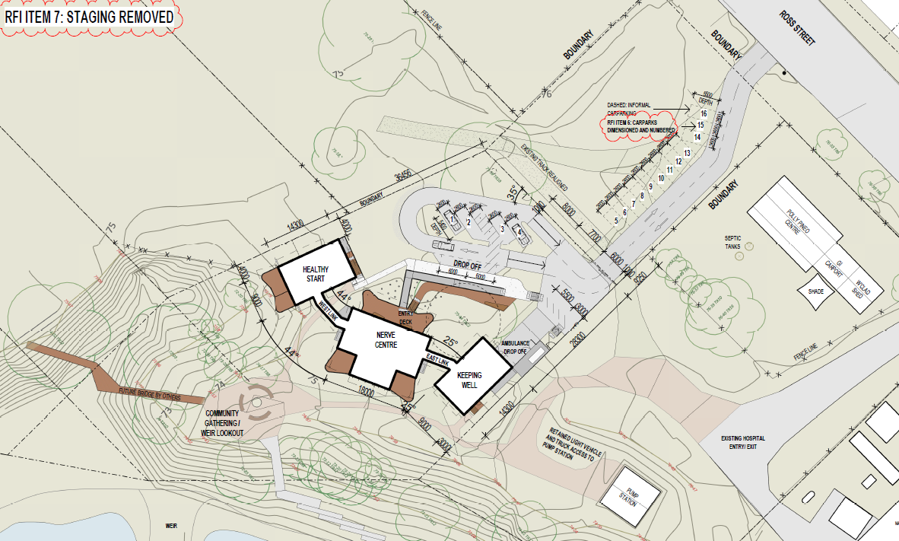
2.2 Project need and justification
As described on its website, ‘Maari Ma Health is an Aboriginal community-controlled health organisation dedicated to improving the health outcomes for communities in the far west region of New South Wales with a special focus on Aboriginal health.
Maari Ma was established in November, 1995, following extensive community consultation conducted on behalf of the Murdi Paaki ATSIC Regional Council.
Maari Ma is lead and governed by an all Aboriginal Board of Directors, democratically elected to represent 7 communities in our region: Broken Hill, Ivanhoe, Balranald, Menindee, Wilcannia, Wentworth Shires and Tibooburra from the unincorporated area. The board is deeply committed to providing a holistic approach to Aboriginal health that includes physical, emotional, spiritual, cultural and environmental dimensions.
We deliver services to Aboriginal people and their families, and work closely with mainstream agencies to provide access to a broad range of services. Since our incorporation, Maari Ma has built strong local strategic partnerships. Maari Ma also strives to build and nurture partnerships with our communities as their participation in the planning and implementation of health and social programs is essential not only to quality health care but also to the integration of public health programs in our communities and improved community well-being’.
Maari Ma currently operates out of a smaller, older premises at 14 Ross Street, Wilcannia.
2.3 Strategic context
Being adjacent to the banks of the Darling River also holds significant cultural importance. Wilcannia is the traditional home of the Barkandji people, who have a cultural and spiritual link to the river. The river and its banks are likely to have greater archaeological sensitivity, reflecting these links and the history of Aboriginal occupation near the waterway.
There is a strong demand for the improvement of services in the region, particularly for improved quality of care outside of a hospital setting, noting that Wilcannia Hospital was re-developed as a multi-purpose facility in 2002.

            - STATUTORY CONTEXT
3.1 Zoning
The land subject of this development application is zoned Part R1 – General Residential and Part W1 – Natural Waterways.
3.2 Permissibility
The development can be defined as a ‘health services facility’, defined by Central Darling Local Environmental Plan 2012 as:
health services facility means a building or place used to provide medical or other services relating to the maintenance or improvement of the health, or the restoration to health, of persons or the prevention of disease in or treatment of injury to persons, and includes any of the following—
(a) a medical centre,
(b) community health service facilities,
(c) health consulting rooms,
(d) patient transport facilities, including helipads and ambulance facilities,
(e) hospital.
There are elements of each of (a)-(d) in the proposal.
A health services facility is permissible on that part of the land zoned R1 General Residential zone, with development consent.
Zone R1 General Residential
1 Objectives of zone
• To provide for the housing needs of the community.
• To provide for a variety of housing types and densities.
• To enable other land uses that provide facilities or services to meet the day to day needs of residents.
• To minimise land use conflict between land uses on land within the zone and land uses on land within adjoining zones.
2 Permitted without consent
Environmental protection works; Home-based child care; Home occupations; Roads; Water reticulation systems
3 Permitted with consent
Attached dwellings; Boarding houses; Building identification signs; Business identification signs; Car parks; Centre-based child care facilities; Commercial premises; Community facilities; Dwelling houses; Food and drink premises; Function centres; Group homes; Hostels; Kiosks; Multi dwelling housing; Neighbourhood shops; Oyster aquaculture; Places of public worship; Pond-based aquaculture; Public administration buildings; Registered clubs; Residential flat buildings; Respite day care centres; Semi-detached dwellings; Seniors housing; Shop top housing; Tank-based aquaculture; Tourist and visitor accommodation; Waste or resource transfer stations; Water recycling facilities; Water treatment facilities; Any other development not specified in item 2 or 4
4 Prohibited
Agriculture; Air transport facilities; Airstrips; Amusement centres; Animal boarding or training establishments; Biosolids treatment facilities; Boat building and repair facilities; Charter and tourism boating facilities; Correctional centres; Crematoria; Depots; Electricity generating works; Entertainment facilities; Extractive industries; Farm buildings; Farm stay accommodation; Forestry; Freight transport facilities; Heavy industrial storage establishments; Helipads; Highway service centres; Industrial retail outlets; Industrial training facilities; Industries; Marinas; Mooring pens; Moorings; Mortuaries; Open cut mining; Recreation facilities (major); Research stations; Restricted premises; Rural industries; Rural workers’ dwellings; Service stations; Sewage treatment plants; Sex services premises; Signage; Storage premises; Transport depots; Truck depots; Vehicle body repair workshops; Vehicle repair stations; Warehouse or distribution centres; Waste or resource management facilities; Wharf or boating facilities; Wholesale supplies
Zone W1 Natural Waterways
1 Objectives of zone
• To protect the ecological and scenic values of natural waterways.
• To prevent development that would have an adverse effect on the natural values of waterways in this zone.
• To provide for sustainable fishing industries and recreational fishing.
2 Permitted without consent
Nil
3 Permitted with consent
Airstrips; Aquaculture; Boat launching ramps; Boat sheds; Building identification signs; Business identification signs; Community facilities; Emergency services facilities; Environmental facilities; Environmental protection works; Flood mitigation works; Heliports; Information and education facilities; Jetties; Mooring pens; Moorings; Recreation areas; Research stations; Roads; Water recreation structures; Water recycling facilities; Water supply systems; Wharf or boating facilities
4 Prohibited
Business premises; Hotel or motel accommodation; Industries; Multi dwelling housing; Recreation facilities (major); Residential flat buildings; Restricted premises; Retail premises; Seniors housing; Service stations; Warehouse or distribution centres; Any other development not specified in item 2 or 3
On that part of the land zoned W1 Natural Waterways, no buildings are proposed. However, the depicted pathway at the southern part of the site, from the proposed community gathering/lookout area, enters the W1 zoned land on the slopes/bank of the Darling River. Works beyond the boundary of that part of the site (Lot 111 in DP 1201028) in this location enter Crown Land. The applicant will need to contact the NSW Department of Planning, Industry & Environment – Crown Lands (Western Lands Advisory Committee) before any works occur in that location. This requirement is included as a condition in the draft consent. The legalities of non-tidal water as a boundary are complex and it is noted that the Deposited Plan (DP1201028) has not been investigated by the Registrar General.
3.3 Integrated Development
The subject land, specifically Lot 111 in DP 1201028 and Lot 4 in DP 1201089, has a frontage of approximately 89m to the Darling River. On this basis, the proposal was referred to the NSW Natural Recourses Access Regulator (NRAR) as integrated development as the development is classified as 'Integrated Development' under section 4.46 of the Environmental Planning and Assessment Act 1979, as concurrent approval is required from NRAR under the Water Management Act 2000.
The applicant must obtain a controlled activity (works) on waterfront land, the consent holder must obtain a Controlled Activity Approval under the Water Management Act 2000 from NRAR. Waterfront land for the purposes of this development application is land and material in or within 40m of the top of the bank or shore of the Darling River.
At the time or preparing this report, a response has not yet been received. We will include a condition in the draft consent requiring the development to comply with any General Terms of Approval provided by NRAR.
3.4 Consideration of Environmental Planning Instruments and DCPs
Under section 4.15 of the Environmental Planning & Assessment Act 1979, the consent authority is required to take into consideration any environmental planning instrument, planning agreement, the Regulation and development control plan that is of relevance to the development the subject of the development application. Therefore, this assessment report includes an assessment (including impacts, suitability of the site and the public interest) against the provisions of the following:
- State Environmental Planning Policy (Planning Systems) 2021
- State Environmental Planning Policy (Resilience and Hazards) 2021
- Central Darling Shire Local Environmental Plan 2012
We have undertaken a detailed assessment of these environmental planning instruments in Part 5 of this report and we are satisfied that the proposal is consistent with their requirements and do not compromise their aims & objectives.
Central Darling Shire Council has no Development Control Plans over this land.
3.5 The objects of the Environmental Planning & Assessment Act 1979
The objects of the Act and our consideration against those objects is demonstrated in the following table:
Object | Consideration
(a) to promote the social and economic welfare of the community and a better environment by the proper management, development and conservation of the State’s natural and other resources | The proposal will redevelop land adjacent to the existing hospital and will provide consolidated health services outside of the hospital setting in a more culturally sensitive and comforting setting.
(b) to facilitate ecologically sustainable development by integrating relevant economic, environmental and social considerations in decision-making about environmental planning and assessment | There is no aspect of the development that appears to compromise the principles of ecologically sustainable development.
(c) to promote the orderly and economic use and development of land | The development will meet the objectives of the zone by enabling a land use that provides facilities and services to meet the day to day needs of residents and at the same time, minimise land use conflict within the zone and land uses on land within adjoining zones.
(d) to promote the delivery and maintenance of affordable housing | The provision of housing is not relevant to this development application
(e) to protect the environment, including the conservation of threatened and other species of native animals and plants, ecological communities and their habitats | The proposal will not result in the loss of any threatened or vulnerable species, populations, communities or significant habitats.
(f) to promote the sustainable management of built and cultural heritage (including Aboriginal cultural heritage) | The proposed development is not anticipated to result in any impacts upon built and cultural heritage, including Aboriginal heritage. However, it is recommended that a condition of consent be included requiring works to cease in the event of an unexpected Aboriginal heritage find. Of significant relevance is that the proponent for this development, Maari Ma Health, is an Aboriginal community-controlled health organisation.
(g) to promote good design and amenity of the built environment | We consider that the design of the proposal has had regard to the purpose for which it is being built, as well as being of a scale and bulk that will not detract from the nearby items of environmental heritage.
(h) to promote the proper construction and maintenance of buildings, including the protection of the health and safety of their occupants | The buildings will need to be constructed in accordance with the requirements of the Building Code of Australia as well as having regard to the potential impacts of flooding.
(i) to promote the sharing of the responsibility for environmental planning and assessment between the different levels of government in the State | While the assessment of the development application is undertaken at a local government level, the determination will be made by the independent Regional Planning Panel.
(j) to provide increased opportunity for community participation in environmental planning and assessment | The community has had the opportunity to be involved in this proposal through various stages, including the planning proposal for the reclassification of the land from Community to Operational Land, notification of the development application, public meetings and more recently during advertising of the Voluntary Planning Agreement.

            - CONSULTATIONS AND SUBMISSIONS
Exhibition
The development application was exhibited and notified to surrounding properties for an extended period of 40 days, concluding on 18 February, 2022. No submissions were received.
Public authority submissions
At the time of preparing this report, the Natural Resources Access Regulator had not issued its General Terms of Approval under s4.47 of the Environmental Planning & Assessment Act 1979. The applicant’s attention is drawn to the need to apply to the Natural Resources Access Regulator for the relevant approval if and after development consent has been issued by the consent authority and before the commencement of any work or activity.
In this regard, some precautionary conditions have been included in the recommended draft consent conditions.

            - ASSESSMENT
Section 4.15(1) matter for consideration
5.1 Environmental Planning Instruments

(i) State Environmental Planning Policy (Planning Systems) 2021
The proposal has a capital investment value of $6,356,659. Accordingly, it is Regionally Significant Development under Part 2.4 and Schedule 6 of State Environmental Planning Policy (Planning Systems) 2021 (as it has a CIV of greater than $5 million) and is a ‘health services facility’. For that reason, the development application will need to be determined by the Western Regional Planning Panel.
          - State Environmental Planning Policy (Resilience and Hazards) 2021
There is limited documentation about the post- European occupation history of land uses on the site to be able to determine whether any historic uses have led to the land being contaminated. The land was recently owned by Central Darling Shire Council who indicate that it has, in more recent times, in part been used as an access path for the water pump located to the south-east of the site. There has been no known industrial use of the land and it does not appear to have been subject to illegal dumping of chemicals. Some building materials are scattered on and adjacent to the site, remnants of buildings long since demolished on or near the site.
State Environmental Planning Policy (Resilience and Hazards) 2021 (‘the SEPP’) is the primary environmental planning instrument guiding the remediation of contaminated land in NSW.
The relevant objectives of the SEPP include:

- To provide for a State-wide planning approach to the remediation of contaminated land,

- To specify when consent is required, and when it is not required, for remediation works,

- To specify certain considerations that are relevant in determining development applications in general, and

- Requiring that remediation works meet certain standards and notification requirements.

Clause 4.6 of the SEPP identified that a consent authority must not consent to the carrying out of any development on land unless:
- it has considered whether the land is contaminated, and
- if the land is contaminated, it is satisfied that the land is suitable in its contaminated state (or will be suitable, after remediation) for the purpose for which the development is proposed to be carried out, and
- if the land requires remediation to be made suitable for the purpose for which the development is proposed to be carried out, it is satisfied that the land will be remediated before the land is used for that purpose.

A preliminary site contamination assessment was undertaken by Barnson, who makes the following conclusions:
- Activities associated with the historical and current use of the Subject Site were identified as having a potential to contaminate surface soil at the site.
- Potential sources of contamination were identified on the site including remnants of historical structures, vehicles accessing the site and unclassified fill
- A review of the available historical information, including contaminated sites databases and aerial photographs, indicated a low potential for significant environmental contamination to be present across the site.
- A site investigation and confirmatory soil sampling confirmed that concentrations of all contaminants investigated were below health-risk based screening criteria, for commercial land use, in all surface soil samples collected. Only traces of one persistent pesticide and hydrocarbons were detected in the samples of fill material.
- The highest concentrations of hydrocarbons were detected in the soil sample collected from the drainage channel. The concentrations detected were below both health and ecological screening levels for commercial land use.
- The screening criteria used in the evaluation of the contaminant concentrations were appropriately conservative and suitable for assessment of the proposed commercial land use.
The recommendations of Barnson are:
- Based on the findings of the desktop review and site investigation it can be stated with a reasonable level of confidence that the subject site is suitable for the proposed re-development and land use.
- It is recommended that the stockpiles of fill material as well as demolition waste present at the subject site be removed and appropriately disposed, prior to the commencement of any earthworks or construction.
- It is recommended that any material excavated from the drainage channel or its banks be appropriately classified in terms of the Excavated Natural Materials Order (NSW EPA, 2014) prior to being used on-site or removed off site.

This level of investigation and assessment is considered adequate for this development and for this site. Accordingly, based on the available information, it is recommended that the draft conditions reflect the recommendations of Barnson in its preliminary site contamination assessment.

A search of the NSW EPA Contaminated Land Register on 6 April 2022 did not identify any contaminated lands within the Central Darling Shire.

          - Central Darling Local Environmental Plan 2012
The land is not subject to principle development standards relating to:
- Height
- FSR
- Foreshore building line
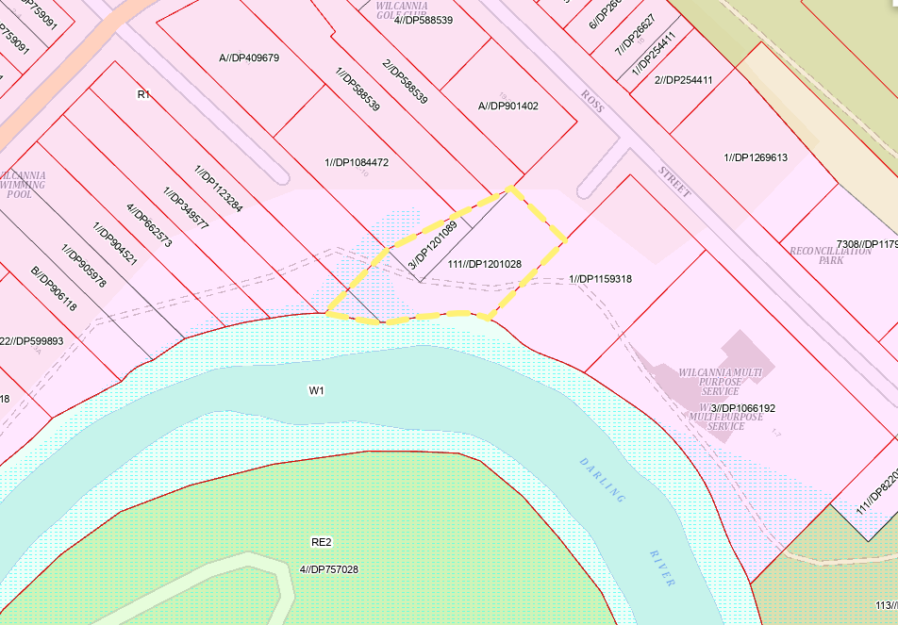
The following clauses of the LEP are of particular relevance to the assessment of this proposal:
1.2 Aims of Plan
(1) This Plan aims to make local environmental planning provisions for land in Central Darling in accordance with the relevant standard environmental planning instrument under section 3.20 of the Act.
(2) The particular aims of this Plan are as follows—
(aa) to protect and promote the use and development of land for arts and cultural activity, including music and other performance arts,
(a) to encourage the proper management of the natural and human-made resources of Central Darling by protecting, enhancing or conserving—
(i) productive agricultural land, and
(ii) timber, minerals, soil, water and other natural resources, and
(iii) areas of significance for nature conservation, and
(iv) areas of high scenic or recreational value, and
(v) places and buildings of archaeological or heritage significance,
(b) to promote ecologically sustainable urban and rural development,
(c) to provide a secure future for agriculture by expanding Central Darling’s economic base and minimising the loss or fragmentation of productive agricultural land,
(d) to minimise land use conflict,
(e) to ensure that development has regard to the capability of the land,
(f) to provide a choice of living opportunities and types of settlement within Central Darling,
(g) to ensure that the efficiency of arterial roads is not adversely affected by development on adjacent land.
Comment:
These aims are the underpinning principles upon which assessment of development in the Central Darling Shire Council local government area is conducted. We make the following conclusions against the relevant aims:
- to protect and promote the use and development of land for cultural activity
The design of the proposal reflects the profound spiritual importance of the Darling River to the Aboriginal people. The community gathering area and each of the buildings will provide a view of the Darling River, something that has been of paramount importance in the design of the proposal.
- protecting, enhancing or conserving areas of high scenic value
The proposal has been designed to take advantage of the site’s proximity to the Darling River and, in particular, the bend of the river where the 1942 constructed (proposed to be replaced under a separate proposal) weir is located.
- protecting, enhancing or conserving buildings of archaeological or heritage significance
Our conclusions are that the proposed development will not compromise the significance of nearby items of European heritage significance.
In terms of Aboriginal history, some further research will need to be undertaken by the applicant (as recommended in the Aboriginal Due Diligence Assessment prepared by Eco Logical Australia and dated 21 April, 2021). This is discussed in more detail in Section 5.4 of this report.
- to promote ecologically sustainable urban and rural development
The findings of this report are that the development has been designed taking into consideration ecologically sustainable principles. Examples of this include the use of solar panels, respect for the Darling River, access to the river, minimal excavation and earthworks, water efficient fixtures and the planting of native and endemic plants throughout the site.
- to minimise land use conflict
The use of the site for a non-residential purpose is unlikely to unreasonably affect the amenity of the residential area, noting that other non-residential land uses are also located in the vicinity of the site. The nature of the proposed use and sufficient management safeguards and recommended conditions of consent should ensure that this remains the case.
- to ensure that development has regard to the capability of the land
The proposal promotes the efficient use of land, does not prevent its orderly development, provides an attractive and modern street frontage and is of a scale and bulk within the environmental capability of the site; that is, the proposal meets the objectives of the LEP and the zone within which it is located.
2.6 Subdivision—consent requirements
(1) Land to which this Plan applies may be subdivided, but only with development consent.
Comment:
Consolidation of the land forms part of this development application.

Land use table
A health services facility is permitted in the R1 General Residential zone. In addition, the provision of a car park on the land comprising the unformed road reserve of Bonney Street is also development permitted with consent. Road construction may take place without consent.
The only aspect of this development that it depicted on the plans as being on land zoned W1 – Natural Waterways is a pathway at the southern part of the site, from the proposed community gathering/lookout area, entering the W1 zoned land on the slopes/bank of the Darling River. Works beyond the boundary of that part of the site (Lot 111 in DP 1201028) in this location enter Crown Land. The applicant will need to contact the NSW Department of Planning, Industry & Environment – Crown Lands (Western Lands Advisory Committee) before any works occur in that location. The legalities of non-tidal water as a boundary are complex and it is noted that the Deposited Plan (DP1201028) has not been investigated by the Registrar General. No objection is raised to this access per se, but the legalities of it in terms of ownership shall be further investigated and cannot form part of this development application.
If this matter can be resolved separately, no objection is raised to a s4.55(1A) application being lodged at a later date for the consideration of Central Darling Shire Council under delegated authority. It is recommended that a condition to this effect be included in the draft recommended development consent conditions.
Part 4 Principal development standards
4.1 Minimum subdivision lot size
Cl4.1(3) – Minimum lot size 800m²
Comment: The land will be consolidated to form a lot with an area of 5,048m².
The proposal complies with clause 4.1 of Central Darling Local Environmental Plan 2012.
5.2 Classification and reclassification of public land
(1) The objective of this clause is to enable the Council to classify or reclassify public land as “operational land” or “community land” in accordance with Part 2 of Chapter 6 of the Local Government Act 1993
Note—
Under the Local Government Act 1993, “public land” is generally land vested in or under the control of a council (other than roads and certain Crown land). The classification or reclassification of public land may also be made by a resolution of the Council under section 31, 32 or 33 of the Local Government Act 1993. Section 30 of that Act enables this Plan to discharge trusts on which public reserves are held if the land is reclassified under this Plan as operational land.
(2) The public land described in Part 1 or Part 2 of Schedule 4 is classified, or reclassified, as operational land for the purposes of the Local Government Act 1993.
……
(4) The public land described in Part 1 of Schedule 4—
(a) does not cease to be a public reserve to the extent (if any) that it is a public reserve, and
(b) continues to be affected by any trusts, estates, interests, dedications, conditions, restrictions or covenants that affected the land before its classification, or reclassification, as operational land.
……’

Comment:
Central Darling Shire Council at its meeting of 20 May, 2021 held a public hearing into the Planning Proposal to reclassify the land from Community Land to Operational Land in order to facilitate the sale of the land to Maari Ma Aboriginal Health Corporation Pty Ltd.
‘It was Resolved that Council will:
1. Receive and note the public hearing report and submissions from the public hearing held on 28 April 2021.
2. Note the public hearing independent chair recommendation that the community members that attended the public hearing on 28 April 2021 did not support the reclassification of the community land to operational land for Lots 2, 3 and 4 DP 1201089, and Lot 111 DP 1201028, Bonney Street Wilcannia.
3. Note that a combined 17 written and verbal submissions were received during the two exhibition periods with all submissions taken into account.
4. Note that more than 10 verbal submissions and one written submission opposing the reclassification were received during the public hearing on 28 April 2021.
5. Note that 20 written submissions were received on 13 May 2021 supporting the planning proposal to reclassify the land from community land to operational land to enable the building of the Maari Ma community health facility.
6. Support the reclassification of the subject land from Community to Operational land.
7. Progress the reclassification process through referring the public hearing report, Council recommendation, planning proposal to reclassify the land and the Submission Summary Report to the Department of Planning, Industry and Environment to consider making the amendment to the Central Darling Local Environmental Plan 2012.’
The amendment to the LEP (specifically Schedule 4 of the LEP) to reclassify the land subject of this development application to Operational Land took place on 13 August, 2021.
Of particular relevance to this development are the comments made by the Council’s Administrator Mr Robert Stewart at the meeting, supporting the proposal in principle:
“Council officers in their report detail the process to where we are at today. I understand the community’s confusion and difference between the Planning Proposal to reclassify the land, the Plan of Management and the need for a lease to permit a DA to be lodged for assessment.
The community rightly has raised concerns about:
1. Flooding,
2. Access for viewing the river,
3. Community benefit.
Wilcannia is built on a floodplain and any development must meet the requirements of the NSW Floodplain Development Manual 2005 and this will be addressed as part of the development application process. The site is in backwater and is not subject to high velocity mainstream flows. The building design will be accompanied by a Flood report by a Flood Engineer.
I also note submissions about viewing the river from the site and suggest that with the construction of the new weir with its increased height and backup and the abundance of public access land along both sides of the river this is not a major issue.
At the end of the day, I must consider the higher long-term public interest in supporting the provision of medical services that this proposed development will bring to the community.”
5.10 Heritage conservation
(1) Objectives The objectives of this clause are as follows—
(a) to conserve the environmental heritage of Central Darling,
(b) to conserve the heritage significance of heritage items and heritage conservation areas, including associated fabric, settings and views,
(c) to conserve archaeological sites,
(d) to conserve Aboriginal objects and Aboriginal places of heritage significance.
(5) Heritage assessment The consent authority may, before granting consent to any development—
(a) on land on which a heritage item is located, or
(b) on land that is within a heritage conservation area, or
(c) on land that is within the vicinity of land referred to in paragraph (a) or (b),
require a heritage management document to be prepared that assesses the extent to which the carrying out of the proposed development would affect the heritage significance of the heritage item or heritage conservation area concerned.
Comment:
We consider that there is ample curtilage around the site to provide an acceptable buffer between the various buildings listed as heritage items in the vicinity such that it will not dominate, detract or compete with those heritage items. Increasing the setbacks and/or reducing the scale of the proposed buildings is considered unlikely to have any noticeable beneficial impact in terms of visual impact. The setting and views of those heritage items from the greater public domain (i.e Ross Street) will be unaffected by the proposed development.
In terms of the potential impact on nearby items of environmental heritage, we do not consider that any impacts are so great that it would be necessary to request a heritage management document.
5.21 Flood planning
(1) The objectives of this clause are as follows—
(a) to minimise the flood risk to life and property associated with the use of land,
(b) to allow development on land that is compatible with the flood function and behaviour on the land, taking into account projected changes as a result of climate change,
(c) to avoid adverse or cumulative impacts on flood behaviour and the environment,
(d) to enable the safe occupation and efficient evacuation of people in the event of a flood.
(2) Development consent must not be granted to development on land the consent authority considers to be within the flood planning area unless the consent authority is satisfied the development—
(a) is compatible with the flood function and behaviour on the land, and
(b) will not adversely affect flood behaviour in a way that results in detrimental increases in the potential flood affectation of other development or properties, and
(c) will not adversely affect the safe occupation and efficient evacuation of people or exceed the capacity of existing evacuation routes for the surrounding area in the event of a flood, and
(d) incorporates appropriate measures to manage risk to life in the event of a flood, and
(e) will not adversely affect the environment or cause avoidable erosion, siltation, destruction of riparian vegetation or a reduction in the stability of river banks or watercourses.
(3) In deciding whether to grant development consent on land to which this clause applies, the consent authority must consider the following matters—
(a) the impact of the development on projected changes to flood behaviour as a result of climate change,
(b) the intended design and scale of buildings resulting from the development,
(c) whether the development incorporates measures to minimise the risk to life and ensure the safe evacuation of people in the event of a flood,
(d) the potential to modify, relocate or remove buildings resulting from development if the surrounding area is impacted by flooding or coastal erosion.
(4) A word or expression used in this clause has the same meaning as it has in the Considering Flooding in Land Use Planning Guideline unless it is otherwise defined in this clause.
(5) In this clause—
Considering Flooding in Land Use Planning Guideline means the Considering Flooding in Land Use Planning Guideline published on the Department’s website on 14 July 2021.
flood planning area has the same meaning as it has in the Floodplain Development Manual.
Floodplain Development Manual means the Floodplain Development Manual(ISBN 0 7347 5476 0) published by the NSW Government in April 2005.
Comment:
A detailed summary of the proposal and the possible impact of flooding of the site have been assessed below under ‘5.2 Key Assessment Issues’.
Part 6 Additional local provisions
6.1 Earthworks
(1) The objective of this clause is to ensure that earthworks for which development consent is required will not have a detrimental impact on environmental functions and processes, neighbouring uses, cultural or heritage items or features of the surrounding land.
(2) Development consent is required for earthworks unless—
(a) the earthworks are exempt development under this Plan or another applicable environmental planning instrument, or
(b) the earthworks are ancillary to development that is permitted without consent under this Plan or to development for which development consent has been given.
(3) Before granting development consent for earthworks (or for development involving ancillary earthworks), the consent authority must consider the following matters—
(a) the likely disruption of, or any detrimental effect on, drainage patterns and soil stability in the locality of the development,
(b) the effect of the development on the likely future use or redevelopment of the land,
(c) the quality of the fill or the soil to be excavated, or both,
(d) the effect of the development on the existing and likely amenity of adjoining properties,
(e) the source of any fill material and the destination of any excavated material,
(f) the likelihood of disturbing relics,
(g) the proximity to, and potential for adverse impacts on, any waterway, drinking water catchment or environmentally sensitive area,
(h) any appropriate measures proposed to avoid, minimise or mitigate the impacts of the development.
Note—
The National Parks & Wildlife Act 1974, particularly section 86, deals with harming Aboriginal objects.
Comment:
Very limited earthworks are proposed as part of this development. Instead, the applicant is predominantly working with the natural grade of the land and is proposing the structures on steel columns which will work with the lie of the land. No external fill is proposed to be imported to the site and the earthworks are limited to ground re-grading to allow the development, roads, pathways, landscaping and drainage to occur.
Precautionary conditions are included in the event of any historical find of Aboriginal significance or importance.
6.4 Essential services
Development consent must not be granted to development unless the consent authority is satisfied that any of the following services that are essential for the development are available or that adequate arrangements have been made to make them available when required—
(a) the supply of water,
(b) the supply of electricity,
(c) the disposal and management of sewage,
(d) stormwater drainage or on-site conservation,
(e) suitable vehicular access.
Comment:
Wilcannia is serviced by a dual reticulated water supply scheme delivering both potable and raw water. During times of no flow in the river when the existing weirpool is too low or of poor raw water quality, water is sourced from 2 ground water bores constructed downstream of the existing weir. Bore water cannot be used as the sole source of supply as the bore yields are not sufficient to supply the potable and non-potable water demands for the town.

Electricity is available to the site.
Sewage disposal will be utilised via on-site septic tank and absorption trench.
Stormwater matters are addressed by way of draft conditions.
The applicant is proposing to install 4 rainwater tanks.
Vehicular access will be upgraded by way of sealed access, driveway, pathways and carparking. Access and 14 parking space will be provided on the existing non-sealed Bonney Street road reserve as part of the Voluntary Planning Agreement.
In assessing this development application, we are confident that the land is or is capable of complying with the requirements of clause 6.4 of the LEP.
5.2 Key assessment issues
- Flooding
- Voluntary Planning Agreement
- Ownership
- Continued public access to the Darling River
- Matters raised by the Western Regional Planning Panel at the briefing held on 15 February, 2022.
Flooding
A flood study report (dated 1 April 2022) was prepared for the Wilcannia Wellbeing Centre by Tonkin (the Tonkin Report). The assessment is constrained by the lack of any overall flood study for the Darling River around Wilcannia to establish a definitive 1 in 100 years flood level. This means that the evidence based on historical flood records is necessary to determine the appropriateness of the nominated floor level in the proposed design. A review of the available information and evidence is detailed below.
1. The Tonkin Report cites an article from 2005 in the local community newsletter Wilcannia News which identified notable floods from 1879 to 2001 and noted the 1976 flood as the highest during that period. This would provide a close estimate of the 100 years ARI flood (1% AEP) based on records over 100 years.
2. The flow data for the flow over the weir at the Wilcannia flood gauge was independently reviewed since the 1930’s and this also identified the flow at the gauge on 5 April 1976 as the highest level. The Tonkin Report noted this flow as 68,804 ML/day. The height on the gauge was noted as 11.592 m.
3. The flood marker on the ablutions block at the caravan park (directly opposite the site on the other side of the river) represents the highest recorded water level and this is at 76.655 m AHD for the 1976 flood.
4. The Tonkin Report also notes that the Bureau of Meteorology’s flood frequency analysis tool estimates a 1 in 100-year flood to discharge as 850 cumec (73,440 ML/day) of flow along the Darling River at Wilcannia. This is slightly (7%) greater than the recorded discharge during the 1976 flood.
5. In reviewing additional flow data from the records, a flood on 23 June 1990 reached a level of 11.00 m on the gauge with a flow of 47,747 ML/day. Comparing the 1976 flood to the 1990 flood, the gauge height rise of 0.592 m equated to a flow difference of 21,057 ML/day.
6. Conservatively, utilising that same gauge height rise rate as above, a 100 years discharge flow of 73,440 ML/day compared to 1976 flood flow rate of 68,804 ML/day would equate to a rise on the gauge of 0.130m.
7. Based on the 1976 recorded flood level of RL 76.655 m AHD and the rise of 0.13m this would set a 100 years ARI (1% AEP) flood level at the development site of RL 76.785 m AHD. Applying a 0.5 m freeboard would set a minimum floor level based on flooding at RL 77.285 m AHD.
The ‘Flood Levels Wilcannia Health Clinic’ report by Barnson Pty Ltd dated 13 May 2021 identifies that the proposed floor level of RL 77.42 m AHD matches the floor level of the adjacent hospital Based on this and the assessment above the proposed finished floor level of 77.42 m AHD is supported.
To better manage the flooding, additional conditions are recommended to ensure structural protection to the buildings during a flood and by requiring a flood management plan to better manage the impacts of the floods both during and after a major flood event.
Voluntary Planning Agreement
A draft Voluntary Planning Agreement (VPA) has been prepared as no Section 7.11 Contributions Plan applies. The applicant has sent to Council an offer to enter into a VPA and this has been accepted by Council and VPA is now being finalised. The VPA will simply include the requirement for the delivery of the infrastructure works required in Bonney Street to enable suitable pedestrian and vehicular access to the site and the provision of carparking prior to the issue of the Occupation Certificate as this is the only offsite works required to be undertaken by the applicant. The VPA will be required to be publicly notified for 28 days before being reported to Council for its endorsement to execute. It is anticipated that the resolution by the Council will take place in Council's ordinary meeting in the coming months.
Ownership
The land has been sold to Maari Ma and is freehold land. The contracts were exchanged on 23 May, 2022. Any Native Title claims have been extinguished on that basis. The former Community Land became Operational Land to facilitate the sale. All of this has been documented on the Council’s website through public hearings and minuted meetings.
Continued public access to the Darling River
It was evident on a site inspection that access to the waters of the Darling River is more convenient in other locations than this, although being community land up until recently, access had never been denied to the general public. The applicant does not intend on restricting public access to the foreshore, but aims to improve it. Future works will be undertaken to provide public access to the site from Field Street to the west. This development application also depicts extended access from the site to the foreshore area over Crown Land. As outlined earlier in this report, this needs to be further investigated by the applicant and Central Darling Shire Council. It need not hinder the assessment of this development application and can be done separately to a Part 4 process.
Access to the community gathering area/weir lookout will be provided off the Crown land adjacent to the site near the existing pump house. This area is depicted on the site plan. Access to the river from that point will be maintained and possibly enhanced in the future once the issue of constructing a path over Crown land has been resolved.
Matters raised by the Western Regional Planning Panel at the briefing held on 15 February, 2022
The Panel raised the following matters requiring further assessment consideration
- Few site controls as Council does not have a DCP
Comment:
We have considered the proposed use, the design, size and bulk of the proposal, its setbacks and proximity to various items of environmental heritage and consider that the development is appropriate for the site. The extent of landscaping proposed is also considered appropriate for its setting adjacent to the banks of the Darling River.
- European heritage – possible contextual issues as design may not quite fit with heritage buildings around it
Comment:
We consider that there is ample curtilage around the site to provide an acceptable buffer between the various buildings listed as heritage items in the vicinity such that it will not dominate, detract or compete with those heritage items. Increasing the setbacks and/or reducing the scale of the proposed buildings is considered unlikely to have any noticeable beneficial impact in terms of visual impact. The setting and views of those heritage items from the greater public domain (i.e Ross Street) will be unaffected by the proposed development.
- OEH concerns around removal of trees and retention of vegetation on the site
Comment:

This issue is addressed in more detail in Sections 5.6 and 5.13 below. The arborist’s report submitted with the DA suggests that there is only one tree of significance on the site and it is being retained. Means of protecting the tree are outlined in the report and shall form part of the recommended consent conditions.
That tree, being a Eucalyptus largiflorens (Black Box), is located in the centre of the site between the ‘Nerve Centre’ and ‘Keeping Well’ buildings.
According to the arborist’s report, the ‘tree contains a basal wound to the south with advanced occlusion and deep wound margins indicative of likely Aboriginal cultural origin and therefore of Aboriginal Cultural Significance’.
The tree is ‘to be retained and will be subject to a major encroachment as per AS4970 (2009) Section 3, 3.3.3 Major Encroachment from development works within >10% of the radial area of the Tree Protection Zone. The TPZ encroachment is approximately 15% which should be sustainable subject to the application of the tree protection works per the Tree Protection Plan and will be mitigated by the use of tree sensitive pier footing for buildings and pedestrian ramps and to a lesser extent by unitary pavers as footpaths near the tree. There is no encroachment into the Structural Root Zones (SRZ) of the retained tree. Much of the soil around the tree appears to be uneven and some is expected to be aeolian sand with natural grade concealed. Therefore, excavation for paths north of the tree may have a reduced impact depending on the finished levels and subject to tree sensitive excavation.
The retention and protection of Tree 1 provides amenity and screening of views within the site subject to some minor pruning and other minor remedial works. The tree has an almost occluded trunk wound which is considered to have been historically modified by Aboriginal cultural activities and therefore is significant as an Aboriginal Scarred Tree. The Tree Protection Zone (TPZ) setbacks and protection specifications for the tree provided in Appendix H - Tree Protection Plan are satisfactory to retain and protect the tree’.
- Bushfire prone land and APZ provisions
Comment:
Bushfire matters are discussed in Section 5.9 of this report.
- Staging of development – confirmation that development is not being staged. The panel requested the amendment of the plan accompanying the application to delete references to staging
Comment:

The applicant amended the site plan which made references to staging of the development. The new plan, issue B is dated 12 April, 2022 and contains no such references.
- Specification of the requirements being sought by Council through the Voluntary Planning Agreement (kerb and gutter, bitumen etc)
Comment:
The draft conditions of consent refer to the Voluntary Planning Agreement and vice versa. The specifics of the infrastructure works include the following:
- A minimum of 16 car parking spaces are required to be provided, being 12 spaces on Bonney Street as part of the Voluntary Planning Agreement and 4 car parking spaces on the site. These are to be designed having minimum internal clear dimensions in accordance with Australian Standard 2890.1 as follows:
        - 2.6 m x 5.4 m
          - Disabled car space: 2.6 m x 5.5 m (plus shared zone)
- All internal driveways and other paved areas shall be designed to provide continuous surface drainage flow paths to approved points of discharge.
- The layout of the proposed car parking areas associated with the subject development (including, driveways, grades, turn paths, sight distance requirements, aisle widths, aisle lengths, and parking bay dimensions) are to be designed in accordance with Australian Standard 2890.1 – 2004 and AS 2890.2 – 2002 for heavy vehicles
- Proposed new roads (i.e the partial construction of Bonney Street) shall be designed and constructed as follows: width – 40m, length- 50m, formation 3.5m-6.0m-3.5m Traffic loading N(E.S.A) – 5 x 104.
- The works within the Bonney Street road reserve are to be offset a minimum of 3.5m from the south eastern boundary to provide a verge area.
- A 1.5m concrete footpath is to be constructed within the verge from Ross Street to the car park area
- Provide a barrier kerb adjacent to the verge
- Provide a minimum 3.0m wide table drain between the paved carpark and northern boundary including suitable scour protection against batters
- Provide a pipe through the proposed carpark fill batter across the bend to collect the upstream table drain and convey this through the site. Size this pipe to take all the flow from Bonney Street and the flow that discharges off Ross Street in a 1 in 100 years flood event, with a minimum 375 mm pipe
- Provide an additional table drain TD3 that extends from the pipe above along the north-west boundary and extending to Bonney Street to align with the future realignment of the discharge from Ross Street
- Provide a new detail for table drain TD3 sized to take all the flow from Bonney Street and the flow that discharges off Ross Street in a 1 in 10 years flood event. Provide calculations
- All required internal driveways and car parking spaces shall be line-marked, sealed with a hard standing, all-weather material to a standard suitable for the intended purpose
- Prior to the issuing of an occupation certificate, any relevant requirements under the Voluntary Planning Agreement made between Central Darling Shire Council and the Maari Ma Health Aboriginal Corporation shall be satisfactorily completed. This condition will not be satisfied until Central Darling Shire Council has given its written certification to this effect
- Assessment report to provide further background to planning history of the site.
Comment:
There is no notable planning history to the site. This planning report contains various references to the potential for contamination, ownership and other relevant matters.
This 1970 display with map depicts the site adjacent to the power and water supply and hospital. It appears evident that where the existing pump station is located, there was once a more substantial building.
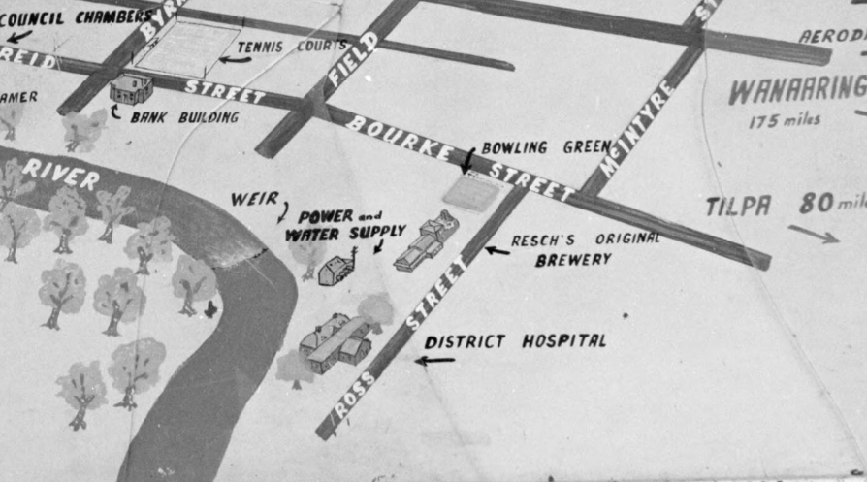
Stacey, Wes (Wesley), 1941- (National Library of Australia)
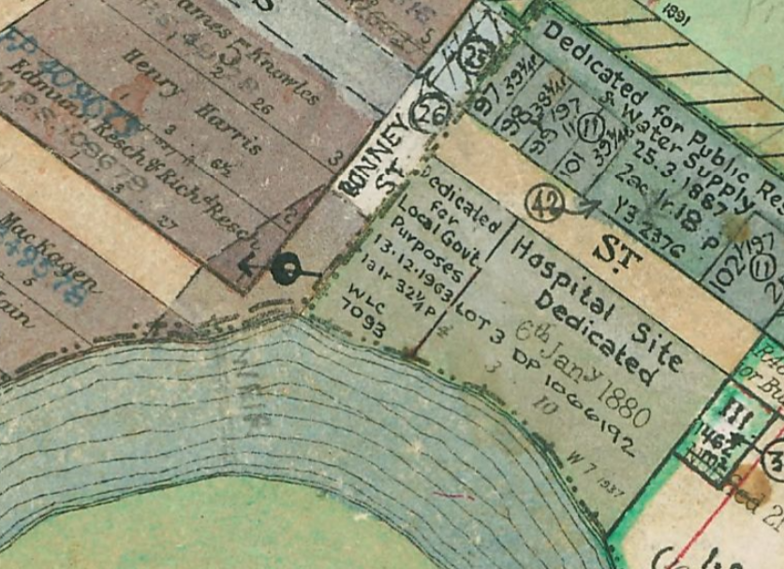
NSW Land Registry Services Parish Map. Site
5.3 Built form and urban design
The design of the building displays a modern appearance, with a scale and colour scheme that is sympathetic to the nearby items of environmental heritage and to the cultural characteristics of the town. The built form will comprise of 3 main elements, each being a single storey structure raised above ground level on steel columns. These buildings will be constructed with fibre cement and metal wall sheeting and metal roofing, with cypress pine and fibreglass mesh decking and decorative metal screens and panels.
The site is not subject to building envelop development standards or controls such as height or floorspace ratio. The maximum height of the buildings (measured from existing ground level to the highest point of the building) is approximately 7.5m, with the bulk of the development being less than 7m as structures will be on metal columns with openings underneath. This height varies due to the slope of the land, the height of the columns and the pitch of the roof in parts.
We have concluded that the built form and design of the proposal is acceptable for the site.
5.4 Aboriginal & Torres Strait Islander Heritage
An Aboriginal Due Diligence Assessment was prepared by Eco Logical Australia and dated 21 April, 2021. This was based on a site inspection by an archaeologist to determine whether any Aboriginal objects are present on the site and to assess the archaeological potential of the study area.
The study concluded that Aboriginal objects were found within the study area and that the proposed works will have the potential to impact Aboriginal sites. Accordingly, further assessment will be required.
This would normally have been integrated development because an Aboriginal Heritage Impact Permit (AHIP) will be required. However, the applicant did not nominate this proposal as integrated development for the National Parks & Wildlife Service to assess. On this basis, the recommendations below must be met prior to the issuing of any construction certificate for the proposal. This is included as a condition in the draft consent.
The recommendations include:
‘Recommendation 1 – Aboriginal Cultural Heritage Assessment (ACHA), Aboriginal community consultation and test excavation
Based on the sensitive nature of the study area and presence of Aboriginal sites, an ACHA should be prepared which would include an impact assessment of the proposed development. The ACHA would entail Aboriginal community consultation following the ‘Aboriginal cultural heritage consultation requirements for proponents 2010’ (DECCW 2010) to identify Aboriginal cultural heritage values through consultation with Aboriginal stakeholders.
Further archaeological assessment including detailed field survey with Aboriginal stakeholders should be undertaken to inform archaeological values across the developable area.
Recommendation 2 – AHIP application
The ACHA can be used to support a future AHIP application to Heritage NSW if Aboriginal sites cannot be avoided by future development. Heritage NSW require that AHIP applications are supported by an approval under Part 4 or Part 5 of the Environmental Planning and Assessment Act 1979 (such as a DA) as a supporting document.
Recommendation 3 – General measures
Aboriginal objects are protected under the NPW Act regardless if they are registered on the Aboriginal Heritage Information Management System (AHIMS) or not. If suspected Aboriginal objects, such as stone artefacts are located during future works, works must cease in the affected area and an archaeologist called in to assess the finds. If the finds are found to be Aboriginal objects, Heritage NSW must be notified under section 89A of the NPW Act. Appropriate management and avoidance or approval under a section 90 AHIP should then be sought if Aboriginal objects are to be moved or harmed.
In the extremely unlikely event that human remains are found, works should immediately cease, and the NSW Police should be contacted. If the remains are suspected to be Aboriginal, Heritage NSW may also be contacted at this time to assist in determining appropriate management.’

The recommendations of the Aboriginal Due Diligence Assessment prepared by Eco Logical Australia dated 21 April, 2021 have been included in the draft conditions consent for the Panel’s consideration.

5.5 European heritage
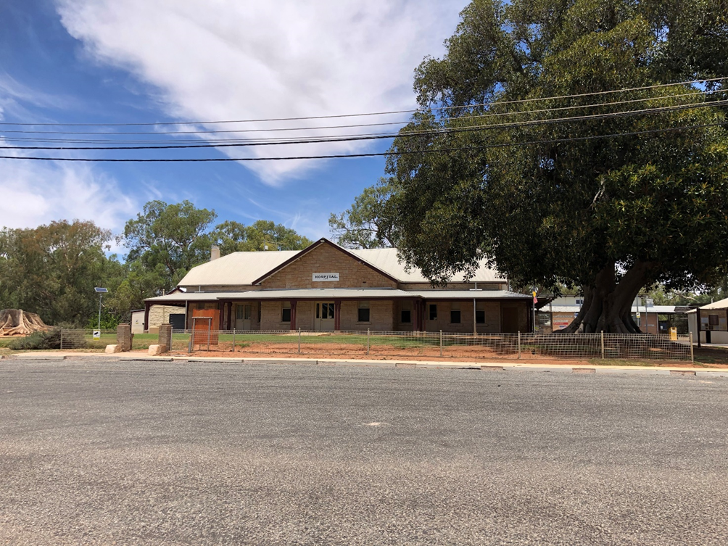
View of the heritage listed hospital building (heritage wing) looking south-west from Ross Street
There are a number of quite significant local items of environmental heritage within proximity of the site. These include:
- The adjacent hospital at 1-7 Ross Street to the east of the site. The hospital was designed by Edmund Blacket, architect of St Andrew’s Cathedral in Sydney and Sydney University and was built in 1879.
- Steam engines and old Wilcannia water tower at 6-8 Ross Street to the north-east of the site. The steam engines were moved to this location after they had been abandoned near the river. The water tower (municipal water cistern) with riveted iron plate water tank and cast iron support tower, supplied the town with water from 1884 until 1977, when the old pumping station was closed down.
- The Wilcannia Golf Club built in 1879 at 25-29 Ross Street to the north-west of the site. This used to be the site of the Lion Brewery built in 1879. Brewing ceased in 1927. A malting tower was demolished in 1975 to make way for the Golf Club and the only remains of the brewery are the random stone walls and small section of stone building incorporated into the 1970s structure.
- 19-23 Bonney Street (house and former brewery residence) adjoining the site to the north. The significance of this building includes it being the manager’s residence for the adjacent Lion Brewery and was constructed between 1875 and 1880, originally owned by Edmund Resch.
(Historic information sourced from the Wilcannia NSW Community Based Heritage Survey 2017 – McDougall & Vines, Conservation and Heritage Consultants)
Overall, the proposed development will not likely affect the integrity of nearby items of environmental heritage and any visual impacts would be minimal.
5.6 Biodiversity
The applicant commissioned a Flora and Fauna Impact Assessment over the subject land. The findings of the as assessment prepared by Eco Logical Australia and dated 3 May, 2021 can be summarised as follows:
- The study area is approximately 5,000m² and comprises 4,441m² of native vegetation and the remainder being vehicular tracks.
- 2 plant type communities are found on the site, Coolabah (River coolah) and Coolabah open woodland wetland with chenopod grassy ground cover on clay floodplain.
- The project will involve developing over 42m² of Coolabah and 2,137m² of the latter, resulting in the proposed removal of 2,179m² of native vegetation.
- The clearing for this project is below the 2,500m² threshold and does not trigger a Biodiversity Development Assessment Report nor entry into the NSW Biodiversity Offsets Scheme.
- The project will not impact on any area mapped on the NSW Biodiversity Values Map.
- Assessments of Significance were undertaken for 10 fauna species and 1 species listed as threatened under the Biodiversity Conservation Act 2016 and undertaken for 1 fauna species and 1 flora species listed under the Environmental Protection and Biodiversity Conservation Act 1999 (all listed in Appendix E and F of the Eco Logical Australia report). Due to the absence of records within the study area, and the proposed impact area, and the presence of suitable habitat for these species upstream and downstream of the Darling River, as well as in areas surrounding the study area, the Assessments of Significance concluded that the project will not result in a significant impact to these threatened fauna or flora species.
- The Assessments of Significance also concluded that the project will not result in a significant impact to any threatened fauna or flora species on or surrounding the study area.
5.7 Traffic and parking
Central Darling Shire has no controls for the provision of carparking for any uses. The former Roads & Traffic Authority Guide to Traffic Generating Developments utilises much of its data based on surveys of uses in the Sydney metropolitan area and is of limited use to a town of the size and location of Wilcannia. However, the applicant has loosely based the proposed allocation of 16 parking spaces on the 2002 guideline prepared by the former RTA as well as reviewing the current needs for Maari Ma’s existing facility in Wilcannia.
Maari Ma also has a small bus which is utilised to transport members of the community to and from the facility (dropping off and collecting from the drop-off area designated at the front of the Nerve Centre building). Based on current generation of 20 movements per day, a bus, 12 staff and visiting medical personel from outside of the region. It is likely that the provision of 16 spaces will be sufficient. In the event that carparking is fully utilised, it is unlikely that street parking will be unavailable at any time.

5.8 Noise and vibration
The premises is only proposed to be operational between the hours of 9.00am to 5.00pm Mondays to Fridays. We consider that there needs to be some flexibility to allow weekend operation on a needs basis when required and for office and administrative functions to occur when the applicant sees fit, despite this not being applied for in the application. Even with those additional possible times and days of potential operation, there is unlikely to be any unreasonable noise emanating from the premises. Standard conditions of consent are nevertheless recommended in the draft consent.
5.9 Bushfire
The lower part of the site is mapped as bushfire prone land with part of the upper site shown as being in the bushfire buffer area.
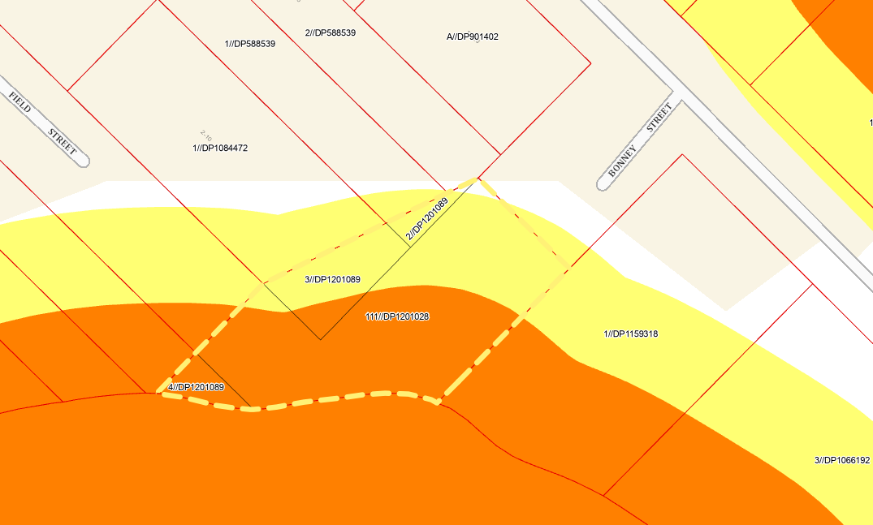
The proposed health services facility is not a ‘special fire protection purpose’ as defined by s100B of the Rural Fires Act 1997, nor is it prescribed by the Rural Fires Regulation 2022, therefore no bush fire safety authority or referral to the Rural Fire Service is required. The proposal is not integrated development for the purposes of the Rural Fires Act 1997 or s4.46(1) of the Environmental Planning & Assessment Act 1979.
However, the applicant has submitted a Bushfire Assessment Report, prepared by Barnson and dated 6 April, 2021. Its recommendations contain a number of bushfire protection measures that must be incorporated in order to ensure that the development can be suitably protected from bushfires and complies with the requirements of the Rural Fire Service’s guide ‘Planning for Bushfire Protection 2019 (A guide for councils, planners, fire authorities and developers)’. These include:
- Asset Projection Zone/Defendable Space

The proposed structure to be located on the site shall be afforded with an Asset Protection Zone (APZ) of 20m for Plots 6 and 7 only as highlighted in the Bushfire Assessment Report. This is the land closest to the Darling River, the river itself and opposite bank. It is recommended that the entire site be managed as an Asset Protection Zone and the APZ’s are to be managed in accordance with Appendix 4 of Planning for Bushfire Protection 2019.

- Landscaping

The applied APZs shall be established and maintained in accordance with Appendix 4 of Planning for Bushfire Protection 2019 and the applicable Asset Protection Zone

- Standards

There shall be no branches overhanging the roof of any proposed structures and new plantings shall be established to ensure that there are no continuous tree canopies.

- Construction Standards

The proposed development is to be constructed to a Bushfire Attack Level (BAL) 19 standard and in accordance with PBP/AS 3959:2009. The BAL does not apply to class 10a storage structures.

- Access

Access to water tanks shall be kept clear at all times.

Any traffic management devices shall not prohibit access for emergency vehicles.

Turning areas as shall be established in accordance with Appendix 3 of Planning for Bushfire Protection 2019.

The access roads shall be constructed to be capable of carrying a fully loaded firefighting vehicle up to 23 tonnes.

All internal roads are to be at least 4m in width and no bridges or causeways are to be constructed, however if required, shall be constructed and maintained in accordance with Planning for Bushfire Protection 2019 provisions.

No tree plantings or obstructions shall occur on either side of the access roads
that would prohibit access to and from the site in the event of fire.

- Services

Water

Reticulated water supply shall be provided with access points and fire hydrants located on the site. The water supply shall be easily accessible for fire fighting vehicles;

▪ Hardened driveways are to be provided to the access points;

▪ Fire hydrants are to be located, spaced, sized and pressured to comply with AS2419.1;

▪ All aboveground water service pipes including taps etc shall be constructed of metal material.

- Electricity and Gas

Vegetation around existing/new transmission lines are to be maintained in accordance with the specifications in ISSC3 Guideline for Managing Vegetation Near Powerlines. (ISSC – Industry Safety Steering Committee)

Any proposed gas bottles shall be installed and maintained in accordance with AS/NZS 1596:2004 with metal piping used.

All fixed cylinders are to be kept clear of flammable materials to a distance of 10m (or appropriately shielded).

All connections are to be of metal construction.

- Bushfire Danger Period

Before the commencement of the Bushfire Danger Period, a review of the vegetation on the site and applied BFPMs is recommended to be undertaken.

Fuel reduction measures are recommended throughout the site.

- Emergency Evacuation Plans:

Preparation of a Bush Fire Emergency Management and Evacuation Plan, in accordance with RFS requirements.

An Emergency Planning Committee is required to be established for the facility in accordance with Planning for Bushfire Protection 2019 requirements.

A Fire Management Plan (FMP) should be prepared for the property that is reviewed and updated annually.

All of these recommendations have been included as draft conditions of consent for the Panel’s consideration.
5.10 Waste management
The facility is unlikely to generated a significant amount of waste. The proponent should contact Central Darling Shire Council and/or a private waste contractor regarding the storage and removal of waste and with NSW Health regarding the disposal of any clinical waste that might arise from the use of the premises.
5.11 Crime prevention through environmental design
The 4 principles of assessing crime minimisation are:
- Surveillance
- Access control
- Territorial enforcement
- Space management
The following comments are made in relation to crime minimisation:
- The location of the car park on and adjoining the street and in front of the building enables compliance with CPTED principles particularly from a passive surveillance (sight lines) and pedestrian vehicle conflict perspective.
- The applicant is proposing external lighting of building perimeters, driveways, pedestrian paths and car parking areas (draft condition included).
- Landscaping has been carefully considered to avoid potential entrapment areas and will be maintained.
- Pedestrian entries are clearly visible to visitors (draft condition included).
- Side boundaries will be fenced.
- Communal areas are highly visible and private/public spaces will be made clear to visitors.
- The applicant has made a commitment to ensure that any damaged or vandalised features are repaired or removed.
- The proposal will provide a community facility and will provide a sense of ownership for the local community.
We do not consider that approval of this development application will create or exacerbate crime risk. In addition, the applicant’s draft Plan of Management already contains protocols for the storage of personal information and items such as prescription pads, medication etc to ensure that it is not readily available to unauthorised users.
The proposal will have to meet all of the relevant requirements of the Disability Discrimination Act 1992. This has been included as a draft condition.
5.12 Disabled access
The proposed development highlights access for all including disabled, mobility impaired and pram access through:
- Accessible ramp access being provided to the 3 inter-connected buildings.
- 2 accessible parking spaces located close to the building entry.
- Ambulance and patient vehicle drop-off area.
- Providing sealed road and pavement access to the site where none currently exists.
- Accessible toilets will be provided in each of the 3 buildings.
5.13 Landscaping & tree retention
There is only one significant tree on the site, that being a Black Box Tree located in the centre of the site and will be retained and protected. This is included as a ‘prior to construction certificate’ draft condition of consent.
The site will also be landscaped with distinct Local Wilcannia traditional artwork and floodplain and river bed theme utilising local materials and 21 species of endemic and native plants. The landscaping will aim to provide interactive engagement opportunities for visitors, as well as rest and gathering spaces located close to the banks of the Darling River.
A draft condition requiring full compliance with the Landscape Plan prior to the issuing of any occupation certificate is included in the draft consent.
5.14 Contamination
The applicant submitted a preliminary site contamination assessment. Its recommendations will form part of the recommended consent conditions.
Concluding, the report makes the following recommendations:
- ‘Based on the findings of the desktop review and site investigation, it can be stated with a reasonable level of confidence that the subject site is suitable for the proposed re-development and land use.
- It is recommended that the stockpiles of fill material as well as demolition waste present at the subject site be removed and appropriately disposed, prior to the commencement of any earthworks or construction.
- It is recommended that any material excavated from the drainage channel or its banks be appropriately classified in terms of the Excavated Natural Materials Order (NSW EPA, 2014) prior to being used on-site or removed off-site.’
It is also recommended that in the event of any unexpected contaminants being found, remediation works will need to be undertaken and a qualified geoscientist must then validate the site to be suitable for the proposed health services facility to the National Environment Protection (Assessment of Site Contamination) Measure 2013 Guidelines.
This is included as a draft condition in the recommended development consent.
5.15 Visual impacts
The landscape and visual amenity of the site is characterised by the presence of the hospital and nearby dwelling houses, with a corridor of riparian vegetation following the river course and the Darling River itself.
The proposal will be a change in the character of the site, but considered to be positive change. There will be minimal change to the natural landscape and landform.
In terms of overshadowing, this is not considered to be a concern. The buildings will be located to the south and well east of any nearby residential properties. Any additional overshadowing at critical times of the day (9.00am – 3.00pm) and year (Winter Solstice) will fall largely across the site itself.
The bulk, scale, design and siting of the proposed development is considered appropriate given its context and the surrounding development.

- CONCLUSION AND RECOMMENDATION
The proposal seeks approval for the construction of a single storey (but elevated over an undercroft area), health services facility, split into 3 separate buildings connected by 2 covered walkways at Bonney Street, Wilcannia. The development also comprises civil works to provide car parking, road works to provide access/parking and landscaping throughout the site.
We have reviewed the documentation submitted by the applicant and taken on advice from the Western Regional Planning Panel.
We are of the view that the recommended conditions and implementation of measures detailed in the Aboriginal Due Diligence Assessment, Plan of Management, Arborist Report, Flood Study, Flora and Fauna Impact Assessment, Bushfire Assessment Report and Contamination Report will adequately mitigate any potential environmental impacts of the proposal. We are also of the view that the amended plan addresses issues previously raised in the early assessment of the proposal.
On balance we consider the site to be suitable for the proposed development and that the proposal in its amended form will be in the public interest given the significant social and health benefits associated with the health services facility, in particular for the Aboriginal community of Wilcannia and its surrounds.
Accordingly, we recommend that this development application be approved, subject to conditions at Attachment 5.

Attachment 1 – Pre-lodgement notes
Attachment 2 – Record of Briefing Western Regional Planning Panel 15 February, 2022
Attachment 3 – Record of Briefing Western Regional Planning Panel 17 May, 2022
Attachment 4 – Copy of plans
Attachment 5 – Draft conditions of consent

